***Ethiopian Community – Focus Group Results***

A focus group with members of Seattle’s Ethiopian community was conducted on May 29, 2013 with the Ethiopian Community in Seattle located in the Rainier Valley. This was part of the *Information Technology Access and Adoption in Seattle: Progress towards digital opportunity and equity* study conducted by the City of Seattle. Twenty-four individuals attended the focus group, in addition to four bilingual note-takers and a bilingual facilitator. Seventeen participants completed at least part of a brief written survey[1]. Participants engaged in the planned focus group activities – a dynamic method that relies on *mutual interviewing* among the community members – with apparent interest and engagement.

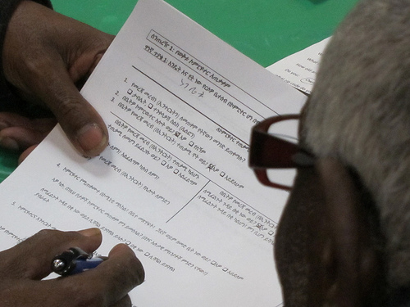

The half that completed the demographic portion of the survey indicated a range of education, with about half completing at least some college and only one person noting that she did not complete high school. Survey respondents were also diverse in age, with 20% in each of the two youngest age categories (18-25 and 26-35), 30% 65 or older, and 30% were between 36 and 64. The handful that indicated income selected less than $20,000 (40%), $20,000 to $30,000 (30%) or $30,000 to $40,000 (30%).

**Summary:**

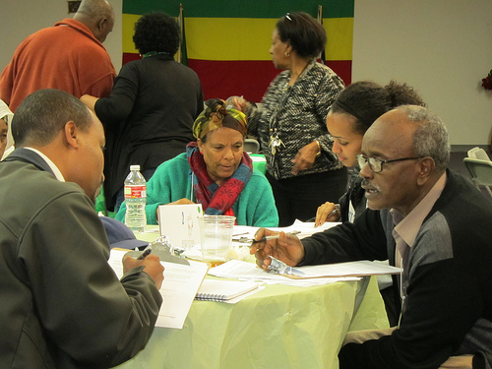Most of the Ethiopian participants are Internet users and positive about computers and the Internet, though with not quite half reporting that they have Internet at home, they described significant barriers to technology access (their own or others'), mainly: 1) lack understanding about computers or the Internet, or not knowing how to use them (well over half, including the group's Internet users, rated their technology skills as relatively low); and 2) the costs of access. Technology access via the library or a community center is important for these participants, including those with home access. Whether current Internet users or not, participants appreciate the Internet as a way to communicate and especially to access valued opportunities for learning, and more information in general, including more information about the city of Seattle. Participants were interested positive about using Facebook to communicate with the City, but few are currently regular Facebook users. Thus this community seems very interested in being well-informed and open to the use of technology for that purpose (among others), but challenged by a lack of technology education for a sizeable minority, and the cost of home access for many. Nearly all of the Internet users without home access want it, and nearly all of the non Internet users want to learn. The most common concern for those who rely on public access computers was not having enough time on them.

Though remaining concerned about the cost of home access, participants were very interested in learning more about using the Internet and most often asked for individual training or less often, short workshops to learn it.

Although participants responded positively to the idea of using Facebook to communicate, a strong theme of personal contact emerged, especially when it comes to *giving* opinions, which participants would rather do in an in-person setting or by mail. This was less important for *getting* information, though even in that case, participants also asked public officials to come in to the community and communicate directly with community members.

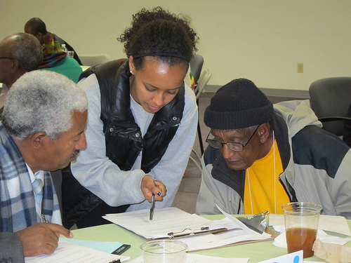**Technology Access and Use**

Of the 16 participants who responded to the *survey* question about home electronics, *none* have a landline, nearly all (94%) have a cell phone and 40% of these have a smartphone. Access to the Internet outside the home is clearly very important to these participants: *Mutual interviewing* notes show that while 83% use the Internet, only half of these (42% overall) have Internet access at home. According to the *survey*, 38% have a computer at home (19% noted a laptop) and none have a tablet. Forty percent of survey respondents indicated that they *use* a computer. During mutual interviewing, 54% said they have a computer at home. When asked "What do you use to get on the Internet?" responses were desktop (46%), laptop (46%), tablet (13%), and cell phone (58%).

Overall, those with home Internet access seemed satisfied with it and the great majority (83%) of those without home Internet access want it. Half of the participants use computers at locations other than home, including 40% of those with home Internet access and 57% of those without. In the survey, 36% indicated that they use the library or a community technology center, 18% checked "school" and 9% checked "Work," "A friend's or relative's" or a "cafe or restaurant." When asked during the interviews if the access away from home was enough for their needs, about two-thirds indicated that it was. The most common concern was not having enough time on the computer.

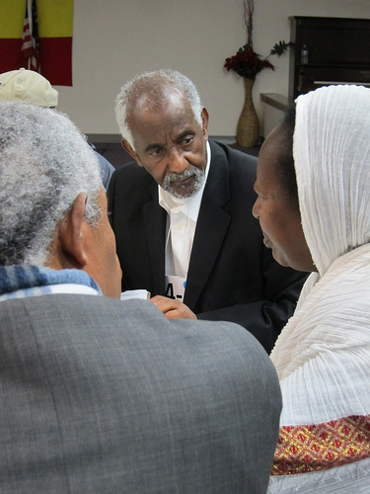Of the people who use the Internet, most (80%) said they don't have any problem with it. When asked what they like best about having a computer or the Internet, one-third said they don't use it, usually because of no access. Of the others, 62% value being able to learn new things or get needed information, and 31% mentioned the speed at which they can get information. About a quarter noted the ability to communicate easily with others and another 38% noted the convenience or sense of freedom provided by Internet access. Those who don't have home Internet access or are not Internet users, but want it would use it to learn or get information (69%) or to communicate (13%). One person simply said he would use the Internet "For everything." When answering the survey question asking why they or others they know do not have computers or Internet, 44% thought it is because people don't know about it or don't know how to use it. Another fairly common response was service problems (31%), followed by the cost of the computer (25%) or the cost of Internet service (19%). When talking about their own lack of use or lack of home Internet access, these ratios were reversed with 44% saying it is because they can't afford the Internet access and 25% saying it is because of not having the knowledge or education to use it.

**Why participants like or want Internet**

* I can send email, I can talk to people, I can learn a lot of things with it, it helps to learn the truth.
* I don't have it at home, but I use it other places and helps me to know more info. That makes me happier.
* I can do whatever I want and I can learn new things every day
* I will be happy to get all information sitting in my house
* It helps us to get all information and to develop my knowledge. Also to get fast information.
* To get information from all over the world.

In the survey, about two-thirds (69%) of the responding participants noted at least one way they use computers. Participants selected an average of four uses, most often "search the Internet" (56%), "find health information" (44%), or "get information about local business" (38%). Some (25% each) use the computer to "attend a class or webinar" or "look for answers to computer problems." Fewer use computers to "work from home" (20%), "get community information" or "shop online" (19% each), or "check on kids' school," "visit the library," or "watch TV" (13% each). None selected "sell goods or services" or "contribute to a blog or wiki."

Thirteen people rated their skill level with computers, starting at "None or not very skilled" (31%), and increasing to "Know what I need to know" (31%), "Can figure out new programs as I need them" (23%), and "Skilled (sometimes help others)" (15%). None of these participants rated themselves as "Expert."

Survey respondents reported least satisfaction with the cost of the Internet service (33% said they were satisfied) and were most likely to indicate "price" as the one thing that would most improve their Internet service (63%). While most respondents were satisfied with their Internet speed (86%), reliability (100%), and customer service (83%), 25% checked "customer service" as the one thing that would most improve their Internet service.

When asked how much, if anything, they would be willing to pay per month for Internet access or for faster access, 30% of the 10 respondents checked "Nothing." Another 30% checked a box between "Less than $5" and $10-$20. Twenty percent indicated $30 - $40, and another 20% indicated $40-$50.

**Interested in super high speed Internet?**

* Yes. To contact my doc and nurse from home. To communicate with others. I will continue to learn. Then I will help others.
* I can't do it now but if I get the education, I can benefit from it.
* Culturally not used to using Internet
* Not really, don't really want something that keeps (to) themselves without interacting with others (physically)
* yes, I am thinking I will communicate with my doctor, online education. I will help others who need my help
* I have used most of the services that are listed except for visiting my doctor without leaving home.

**High Speed Internet**

One group explored participants' perspective on super high speed Internet, asking if they'd be interested in a few sample applications or other applications, and asking about concerns about the service.

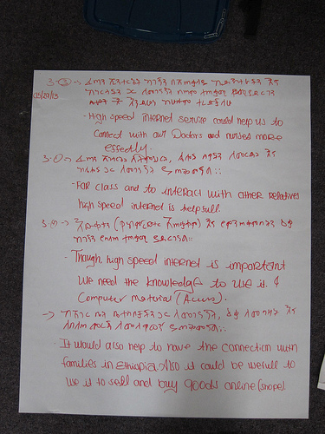The majority (60%) said they would be interested in trying the super-high-speed service. About a quarter were not interested. Those who were interested identified a particular inclination toward attending medical appointments from home (40%), and communicating with family over Skype (52%) - though as one person pointed out it can be difficult for this population because family in Ethiopia may not have adequate service to complete a call. Twenty-eight percent are interested in online learning, though one person pointed out that without the social interactions, it can be difficult to learn in that way, and 20% expressed an interest in helping others, perhaps thinking of the monitoring function or teaching others in the community. Another 20% mentioned an interest in online shopping and two mentioned using online bill pay.

The greatest concerns are not having the knowledge to use the Internet (52%) or not being able to afford the service (32%). Other issues mentioned include not having a computer, and having to work in English. One person remarked that the Internet isn't really part of their culture and another expressed a concern about losing interpersonal interactions in a world with super high speed Internet access. The box above includes some notes made by the interviewers.

**Cable TV and Video Content**

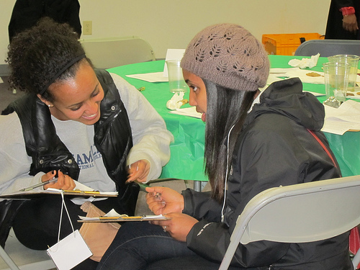The survey asks respondents to rank how they prefer to watch TV programs or movies. Some ranked; others simply checked. Eleven respondents answered this question and nine of these indicated cable (82%), five (45%) checked or ranked "Over the Internet," and four (36%) indicated "Satellite." (One person specified "Ethiopian satellite TV.")

Respondents were *most* satisfied with reliability (71% of responding Cable TV customers) and cable TV customer service (57%), and least satisfied with the cost (33%). Respondents were most likely to select "Price" when asked what one thing would most improve cable TV service (56%) and 33% checked "customer service."

**Seattle.gov and the Seattle Channel**

**I would be more likely to visit Seattle.gov or watch the Seattle Channel more often...**

* To learn the problems facing the city; to watch educational programs.
* If the program is in my native language and also cultural programs; sports; adult education.
* To get the city's current information; to communicate with other people.
* It usually doesn't cover what I'm interested in seeing.
* If discussed in the Ethiopian medias

If the city wishes the city to reach this community through Seattle.gov and the Seattle Channel, apparently a more concerted effort will be required: Most people (80%) have never visited Seattle.gov, and correspondingly, that option was selected by few (13%). On the other hand, although most people (63%) have seen the Seattle Channel (most of those on cable) that was also selected by only 13%.

In mutual interviewing, participants were asked what would make them want to visit Seattle.gov or watch the Seattle Channel more often. Answers were wide ranging. The most frequently mentioned request was to get more information about the City, including current information, communication with others in the city, and problems the city is facing (32%). Others mentioned improvements in programming, including Ethiopian media or Amharic programs, and problems with the participant's TV or TV service. Fewer mentioned an interest in weather, educational programming, and news. Two people knew nothing about Seattle.gov or The Seattle Channel.

**Communicating with the Government**

The City is looking for efficient and effective ways to communicate with residents, including social networking programs like Facebook or Twitter. Mutual interviewing questions and some survey questions explored this possibility with focus group participants. Overall, findings suggest that this group wants to feel more connected with what is happening in the City and would be positive about connecting with the City via Facebook; however, personal contact remains important: especially when it comes to giving opinions, interpersonal contact is valued in this community, preferably in person or via a written letter (this remains especially important to those for whom electronic access remains hard to attain).

**Communicating with local government**

* I can't follow the city information since I have no means.
* To get in touch with the community, more email and other Internet services could be used.
* Reach out to the community and hold discussion.
* Prepare information sharing means from time to time. Provide high speed internet service.

Specifically, when asked how they prefer to make contact with the government, about half of the respondents about half (47%) selected an in-person visit. After that, 40% want to write a letter, 27% prefer to use the telephone, and 20% prefer email.

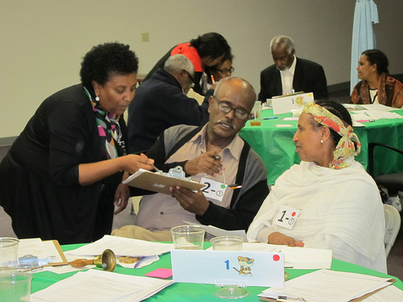Presented with an extensive list of possible ways of *receiving* information from the City, respondents selected their preferences. Responses varied, with nearly 40% selecting each of TV news, newspaper, and email. One-fourth of the respondents selected the radio. *Mutual interviewing* notes indicate that 77% of the participants named at least one technology-based method for getting information, including "email" (41%), "Internet" (50%), or Facebook (9%). In addition, 41% mentioned the use of the telephone and 41% suggested in person meetings (which were not offered as options in the survey list), and 18% suggested a letter. During *mutual interviewing*, few (9%) suggested newspapers and TV.

Respondents were also given an extensive checklist of different communication choices and asked to check how they would like to *give their opinion to* the City. The most commonly selected response was a telephone survey (31%), followed by email or online survey (25%), community meeting (25%), or Facebook (25%). *Mutual interviewing* revealed that participants are more comfortable using technology-based methods to *receive* information than to *give* their opinions. About three-fourths of participants mentioned at least one technology-based method for *getting* information, but only 55% mentioned a technology-based method for *giving* opinions. Those mentioned include email (27%), Facebook (14% - not the same individuals that suggested Facebook for receiving information) or "Internet" (14%). More frequently, participants suggested the use of letters (36%) or in person meetings (36%). The telephone was less likely to be suggested for giving opinions (27%) than for getting information (41%).

**Mutual Interviewing notes about using Facebook to communicate with government**

* It is a good idea, I will use it
* If I get a chance to [educate] myself I will be able to use it... [but now] it won't work for me because I don't know how to use it.
* It is good, timely
* If I have access, I like to use it
* If I have the funds, it is okay
* Yes it works it is a good thing. Not applicable to me. I am not computer user
* No education, I don't know how... I am willing... I see it is a good thing
* It is helpful, there is new info you can get easily

*Survey:* Respondents were asked how often they use or check email, Facebook and Twitter. Of those who responded to the survey, nearly half said they don't use email, nearly two-thirds don't use Facebook, and more than 80% don't use Twitter. Of those who do use email, just over half check it daily. Just over half of the Facebook users check that platform daily, and of the two people who said they use Twitter, one uses it daily.

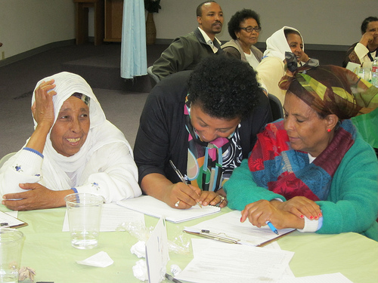

Notes from the *mutual interviewing* process reveal that about 40% of the participants use social networking, and 73% of those who don't use it would like to. All the current or willing social network users were positive about the idea of getting information from or giving information to the City via social networking, commenting that it would “work” and that it is a timely idea. About half of the social networking users said they use social networking to connect directly with others (55%) and as many said they use it to get information or news. Another 27% mentioned the ability to exchange ideas or have a discussion using a social networking platform.

When asked what the participants don't like about social networking sites, answers were scattered, with 18% mentioning a concern about privacy and another 18% mentioning how much time the sites can consume.

Of those who don't use social networking sites, about half said it was because they don't know how to use it or are "not educated," and 36% said it is because they don't have access or because of finances.

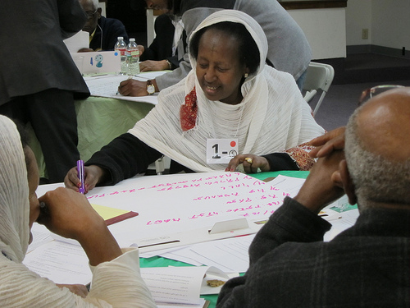Participants were asked, "What do you think the City could do better to help you get information you need or make it easier for you to participate in improving your community?" The most common response (32%) involved coming into the community. Some specified they would like the City to give information, and host a discussion group or question and answer sessions. About one-fourth asked that information be distributed via the media, such as radio or TV. Fourteen percent asked for free wi-fi or that the Internet be made affordable and another 14% asked for training in how to use the technology.

**Learning**

Participants asked each other what they wanted to learn about technology and how they could best learn it. Most frequently (36%), participants said they want to obtain knowledge or gain information and 27% specified that they wanted to learn how to use computer or how to use the Internet (23%). Forty percent asked for individual training and 35% asked for short workshops - a few of these mentioned both teaching modalities.

**What participants want to learn**

* To be knowledgeable and learn about internet.
* To understand Internet and teach others

|  |  |
| --- | --- |
|  | See the full report with other focus groups and survey results at Seattle.gov/tech/indicators   City of Seattle Department of Information Technology  Community Technology Program |

1. Although the survey was well translated into Amharic, this version may have been difficult to understand and to complete by some. Despite the efforts of the bilingual assistants, it appears that the less educated were also less likely to complete the survey.